**CSC 1101 – Problem Solving and Programming Laboratory**

**Lab 14 – [your name]**

**25 points – Due March 11, 11pm**

**a)** Save this document with your name and the homework number somewhere in the file name.

**b)** Type/paste your answers into the document.

**c)** Submit this document and your .cpp file(s) to the Canvas item where you downloaded this document. Do not submit a zip file but individually attach your files.

**[25 points]** You've been hired by *PI Throwers* to write a C++ console application that approximates PI. Use a validation loop to prompt and get from the user the number of terms to approximate PI to that is at least 1. Use the following Leibniz formula:

PI approximation = 4 * (1/1 – 1/3 + 1/5 – 1/7 + 1/9 – 1/11 + …)

The terms appear within the parentheses in the formula. A PI approximation to …

● One term is 4 * (1/1) = 4

● Four terms = 4 * (1/1 – 1/3 + 1/5 – 1/7) = 2.8952380952

● Seven terms = 4 * (1/1 – 1/3 + 1/5 – 1/7 + 1/9 – 1/11 + 1/13) = 3.2837384837

Use a **for statement** to calculate the number that will be multiplied by four. The loop will add and subtract terms to get the number. If **i** is the indexing variable, use condition **i % 2 == 0** to determine whether each loop iteration is even or odd and whether an add or subtract is done. In each term, the dividend is always 1, and the divisor is an odd number starting with 1 that goes up two at a time. Format the approximation to ten decimal places. Use number of terms 1,000 for your last run.

*[your program code here]\**

//==========================================================

//

// Title: PI Throwers

// Course: CSC 1101

// Lab Number: Lab 14

// Author: Trevor Trusty

// Date: 3/8/2019

// Description:

// Takes number of terms from the user to approximate PI with

// using Leibniz formula.

//==========================================================

#include <conio.h> // For function getch()

#include <cstdlib> // For several general-purpose functions

#include <fstream> // For file handling

#include <iomanip> // For formatted output

#include <iostream> // For cin, cout, and system

#include <string> // For string data type

using namespace std; // So "std::cout" may be abbreviated to "cout"

bool iseven(int v) // Call iseven() to test if integer is even

{

if (v % 2 == 0)

{

return true; // Integer is even

}

else

return false; // Integer is odd

}

int main()

{

// Declare variables

double d; // Number of digits to approximate

double x = 1; // Denominator's value

double run = 0; // The result of each loop

// Show application header

cout << "Welcome to PI Throwers!" << endl;

cout << "--------------------------" << endl << endl;

// Read from console

cout << "Enter the amount of digits to approximate pi to, that is at least 1: ";

cin >> d;

while (d < 1) //Validating user input

{

cout << "Catastrophic Failure: response must be at least 1, you entered " << d << '.';

cout << "\n\nEnter the amount of digits to approximate pi to, that is at least 1: ";

cin >> d;

}

for (int i = 1; i <= d; i++)

{

if (iseven(i)) // loop counter is even

{

run -= 1 / x;

x += 2;

}

else //loop counter is odd

{

run += 1 / x;

x += 2;

}

}

run *= 4;

// Write to screen

cout << setprecision(10);

cout << "Approximation:\t" << run << endl;

// Show application close

cout << "\nEnd of PI Throwers" << endl << endl;

// Pause before application window closes

cout << "Press any key to exit ..." << endl;

_getch();

return 0;

}

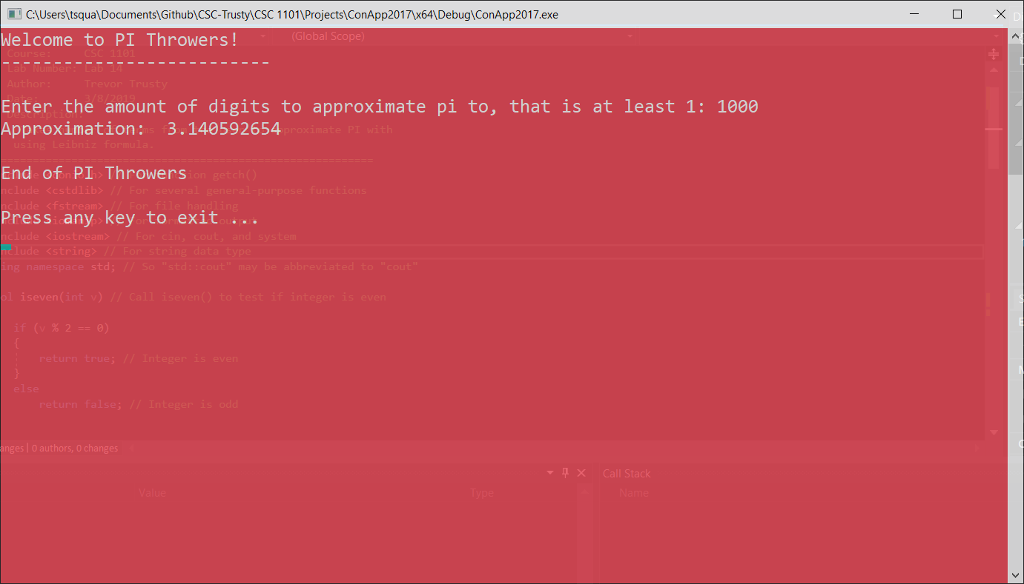

* **Copying-and-pasting Visual C++ code to a Word document**

1) From within the Visual C++ program, press **CTRL-A** and press **CTRL-C**.

2) From within the Word document, press **CTRL-V**.

** **Copying-and-pasting Visual C++ console application output to a Word document**

1) From the Visual C++ console, press **ALT-PrintScreen**.

2) From within the Word document, press **CTRL-V**.